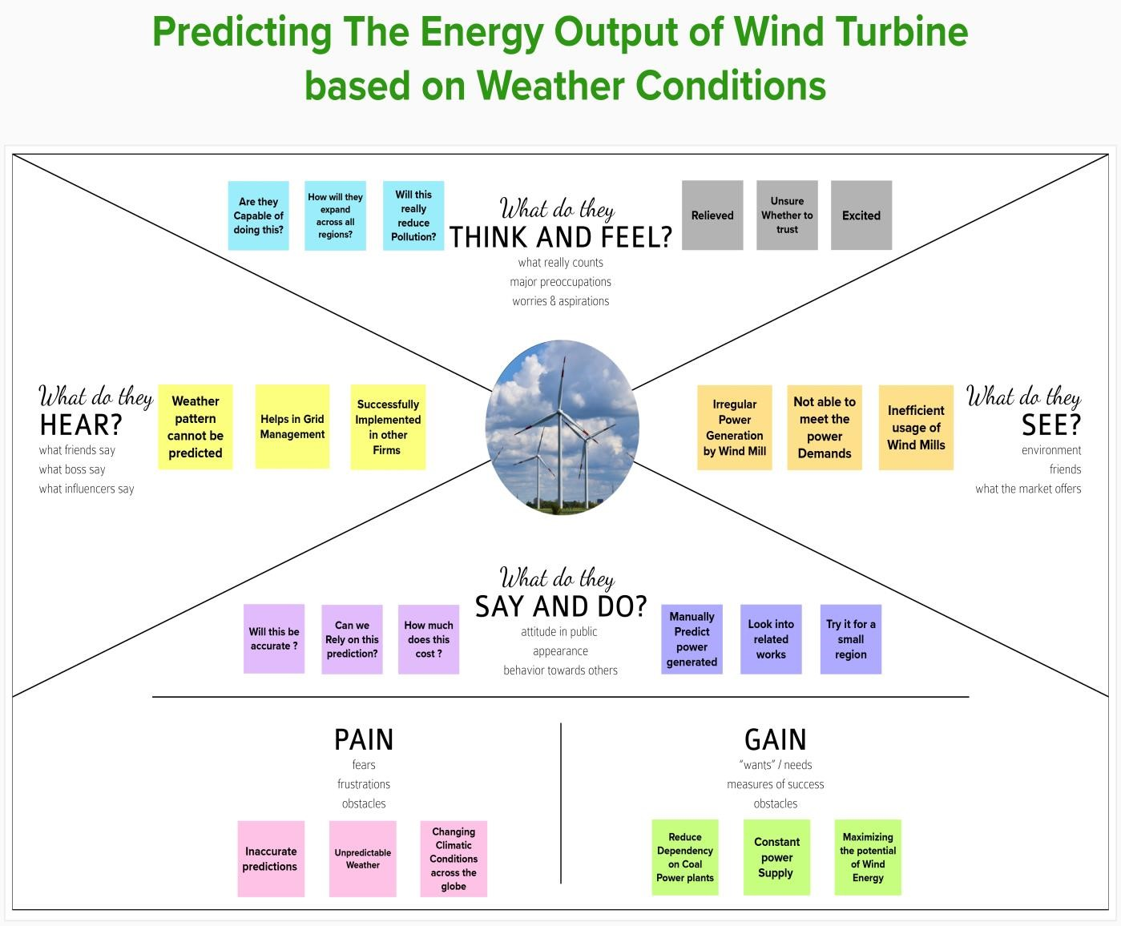
Ideation Phase

Empathize & Discover

Date

08
September 2022

Team ID

PNT2022TMID28577

Project Name

Predicting the energy output of wind
turbine based on weather condition

Maximum Marks

4

Marks

Empathy Map
:

